Science Reviewer
Biodiversity and Evolution
Diversity:
- Species Diversity – Pertains to the total number of species that exist within a habitat or region, as well as the number of individuals composing each species and how they interact with each other and the physical environment. A species is a group of organisms possessing a unique set of characteristics and capable of interbreeding with each other.
- Genetic Diversity – Pertains to the variations in genes (genetic makeup or genotype) within distinct species.
- Ecosystem Diversity – Pertains to the variation of ecosystems in a given place or region and other various types of habitats found within each type.

Biodiversity Loss:
- Biodiversity Loss – Is a phenomenon where the number of species and genetic variations among species are decreasing due to extinction and when specific natural habitats are being lost due to human activities.
- Extinction of Species – Is the number one of biodiversity loss. Extinction means the total disappearance of a species forever.
- Loss of Specific Habitats – Habitat is the place where organisms live
- Loss of Genetic Variations – Within a species means that there exists a limited variety of allelic genes within the species and hence, there are very few differences or variations that exist among the individuals of the same species.
- Categories of Threatened Species
- Least Concern – Means the species population is abundant and widespread.
- Near Threatened – The species is still abundant and widespread but is likely to qualify in threatened category because of rapid habitat loss.
- Vulnerable Category – A species is considered vulnerable when its population has declined by 50% with a known cause, or by 30% with an unknown cause, measured over 10 years or three generations of the species.
- Generation – Means a period of time between birth of the species and the time it is ready to reproduce. Its area of existence is less than 20,000km² and occupies an area less than 2,000km² .
- Endangered – When its population has declined by 70% with a known cause, or by 50% with an unknown cause, or when its extent of occurrence is less than 5,000 km² and its area of occupancy is less than 500 km².
- Critically Endangered – When its population has declined by 90% with a known cause or 80% with an unknown cause, and when its extent of occurrence is less than 100 km² and its area of occupancy is less than 100 km².
- Extinct in the Wild – The species exists only under cultivation (for plants) or in captivity, with no known individuals living in the wild; captive breeding is the process of keeping plants and animals in controlled environments to build a healthy population for reintroduction into their natural habitat.
- Extinct – Not a single specie of the organism exists, whether it is plants, animals, or microorganisms.

Threatened Species in the Philippines:
- Plants:
- Katmon (Dillenia philippinensis) – A medium-sized evergreen flowering plant endemic to the Philippines with an edible fruit known as the elephant apple.
- Waling-waling (Vanda sanderiana) – A species of orchid endemic to Mindanao, an epiphytic plant that is critically endangered due to habitat loss and overcollection.
- Giant staghorn fern (Platycerium grande) – Locally called dapong repolyo, a highly prized epiphytic ornamental plant endemic to Mindanao.
- Arabica coffee (Coffea arabica) – The plant source of the most popular coffee used for commercial production.
- Curran pitogo (Cycas curranii) – A large cycad reaching about 8 meters tall with long, dark green, glossy leaves, endangered in Palawan and Mindoro due to overharvesting and habitat destruction.
- Animals:
- Philippine Eagle (Pithecophaga jefferyi) – Popularly known as the monkey-eating eagle, considered one of the largest and most powerful birds in the world.
- Tamaraw (Bubalus mindorensis) – Sometimes called the dwarf forest buffalo, an animal endemic to the Philippines, specifically on the island of Mindoro.
- Philippine Crocodile (Crocodylus mindorensis) – A freshwater crocodile whose population decline is due to hunting, dynamite fishing, and land clearing.
- Visayan Warty Pig (Sus philippensis) – Once common throughout the Philippines, now found only in Negros and Panay, currently vulnerable.
- Walden’s Hornbill (Aceros waldeni) – Native to Negros and Panay, critically endangered due to excessive hunting and deforestation.
- Tarsiers (Carlito syrichta) – Considered the smallest primates, found in Samar, Leyte, Bohol, and Mindanao, endangered to critically endangered.
- Negros Bleeding Heart Pigeon (Gallicolumba keayi) – A ground-feeding bird found only in Negros and Panay Islands.
- Forest Turtles (Siebenrockiella leytensis) – A freshwater turtle endemic to the Philippines.

Biodiversity:
- Biodiversity – Term used to describe the number and variety of life found on Earth. It is the variety of life on Earth, and high biodiversity means an ecosystem has many species of plants, animals, and microorganisms, with healthy microhabitats, making it stable, resilient, and able to recover from harmful changes
- Biodiversity is important because it gives many benefits. It supports many plants, which means more types of food, shelter, clothing, fuel, medicine, and drugs.
- Living things help their ecosystem by doing things like pollination, spreading seeds, storing and cycling nutrients, forming soil, preventing erosion, and controlling climate.
- Biodiversity is important because it promotes greater variations in the gene pool that will produce new traits among the species.
- Benefits:
- Economic Benefits – Biodiversity provides humans with raw materials for consumption, production, and livelihood.
- Recreation Benefits – Opportunities such as biking, camping, fishing, and hiking.
Scientific Benefits – Biodiversity provides a wealth of information that helps people understand the natural world and its origin.
- Cultural Benefits – The culture of a country is closely connected to biodiversity through identity, spirituality, and aesthetic appreciation.

Natural Causes of Extinction:
- Extreme Heating and Cooling of Earth – The changes in global temperature are caused by several factors that affect biodiversity.
- Changes in Landscape – Various phenomena can change the conditions of species’ habitats; diastrophic movements can uplift landmasses and expose water-dwelling species to the surface.
- Acid Precipitation – Changes in the pH of habitats can disturb bodies of water and cause the death of species.
- Diseases or Epidemics – As the landscape of habitats changes due to climate change, species may lose their immunity to diseases.
- Meteoric Impact or Cosmic Radiation – The impact of a meteorite can destroy large areas, and cosmic radiation from the sun can mutate genes and weaken the gene pool, making species vulnerable to extinction.
- Spread of Invasive Species – Competition arises as invasive species are more efficient in utilizing resources in the area.

Human Activities That Cause Extinction:
- Habitat Destruction – This pertains to the conversion, fragmentation, and simplification of natural habitats and is considered the number one cause of species loss.
- Overharvesting (Overexploitation, Commercial Hunting, and Hunting for Sports) – This is the second major cause of the mass extinction of plant and animal species.
- Introduction of Invasive Alien, Exotic, or Non-native Species – Invasive alien species are organisms introduced by humans, accidentally or intentionally, into areas where they are not naturally present; they are called invasive because they grow, reproduce rapidly, and spread quickly.
- Pollution – The contamination of water, air, or soil by substances harmful to living organisms.
- Water Pollution – Sources fall into direct or point sources and indirect or non-point sources; soil pollutants reach bodies of water through leaching.
- Climate Change/Human Activities – Energy utilization, agriculture, industrial processes, and deforestation have altered the atmosphere, increasing greenhouse gases that intensify the heat-trapping effect, leading to global warming and climate change, which affect terrestrial and aquatic ecosystems.

Ecosystems
Ecosystems in the Philippines:
- The Philippines, an archipelago, has a varied topography. It has many ecosystems: terrestrial, freshwater, estuarine, and saltwater. It has one of the longest coastlines with coral reefs. The Philippines is in the Coral Triangle, home to the world’s greatest marine biodiversity, and is one of the world’s biodiversity hotspots.

Tropical Rainforest
- The Tropical Rainforest – The tropical rainforest is considered the richest ecosystem in the world, home to more than 50% of all terrestrial plants and animals, with nine regions in the Philippines where rainforests can be found.
- Tropical forests are hot and wet all year. Temperatures stay around 21–30°C and humidity is 77–88%. The forest makes most of its rain. Annual rainfall is 200–1000 cm. The stable warm and wet climate keeps trees green all year.
- Structure of Rainforest:
- Emergent or Overstory Layer – The topmost layer of the rainforest, also called the sunlit zone, contains the tallest trees emerging from the lower canopy, receives intense solar radiation, high precipitation, and is extremely windy, with frequent temperature and climate fluctuations.
- Canopy Layer – Located beneath the emergent layer, this dense layer of leaves and branches formed by tall, closely spaced trees (100–130 feet above ground) is considered the roof of the forest, receiving generous sunlight and about 100 inches of rain annually, supporting 90% of rainforest life.
- Understory Layer – The understory layer lies hundreds or thousands of meters below the canopy, with still air and occasional gusts from above, creating an environment that is darker, more humid, colder, and quieter compared to the upper layers.

Estruary:
- Estuary – A partly enclosed water area where freshwater from rivers meets saltwater from the sea. This makes brackish water. Water flows in and out continuously. The head of the estuary gets the most freshwater, while the mouth gets the most seawater.
- Bar-Built Estuary – Forms when a lagoon or bay is surrounded and protected from the ocean by a sand bar, delta, or island parallel to the coast; it is shallow, affected by limited tidal action, and water is mixed by strong winds.
- Coastal Plain Estuary – Forms when sea level rises and floods the mouth of an existing river, the exit point of a river toward a lake or ocean.
- Fjord Estuary – Forms when glacial formation and erosion cut a deep, steep valley that is later filled with ocean waters, ending in a shallow lip-shaped sill.
- Tectonic Estuary – Forms through tectonic activities like faulting and subsidence of coastal lands, creating a space filled with both fresh and salt water, commonly found along fault lines.
- Vegetation in Estuaries:
- Emergent Plants – Those that are rooted at the bottom but with stems and leaves that extend out of the water growing along the shore and in areas where the water is 4-5 feet deep.
- Floating plants – Rooted plants grow with roots in the bottom, but leaves and flowers stay on the surface.
Free-floating plants float on water, and the whole plant moves with wind and water.
- Submerged Plants – Those that are rooted at the bottom and the plant body is entirely underwater.
- Phytoplankton, seaweeds, blue-green algae, mangroves, and seagrasses are the main producers in estuaries, living from the water surface to lower reaches and sometimes anchored or floating.
- Estuarine Habitats:
- Permanent Dwellers – These are true estuarine species that are hardy and stress-tolerant.
- Migratory Visitors – Species that move between freshwater and the sea, including:
- Anadromous – Spawn and breed in freshwater, grow at sea.
- Catadromous – Spawn and breed in the sea, grow, feed, and rest in freshwater.
- Estuarine Fauna – Marine species live at the mouth of the estuary and cannot handle big salinity changes. Brackish water species live in the middle where salinity is 5–18 ppt. Freshwater species live at the head of the estuary with salinity up to 5 ppt.
- Zooplanktons – Small floating animals including copepods, mysids, and amphipods, comprising the largest population in estuaries.
- Invertebrates – The most numerous animal group, providing a rich feeding opportunity for higher-order consumers.
- Birds – High-density and diverse populations thrive on the sand and mudflats of estuaries that are periodically exposed to air.
- Fishes – The main vertebrates that use estuaries as nursery grounds.
Reptiles and Amphibians – The brackish water of estuaries is home to crocodiles, turtles, and various species of snakes.
- Mammals – Considered the apex predators of the estuary ecosystem, including harbor seals, river otters, dugongs, manatees, and sea cows.
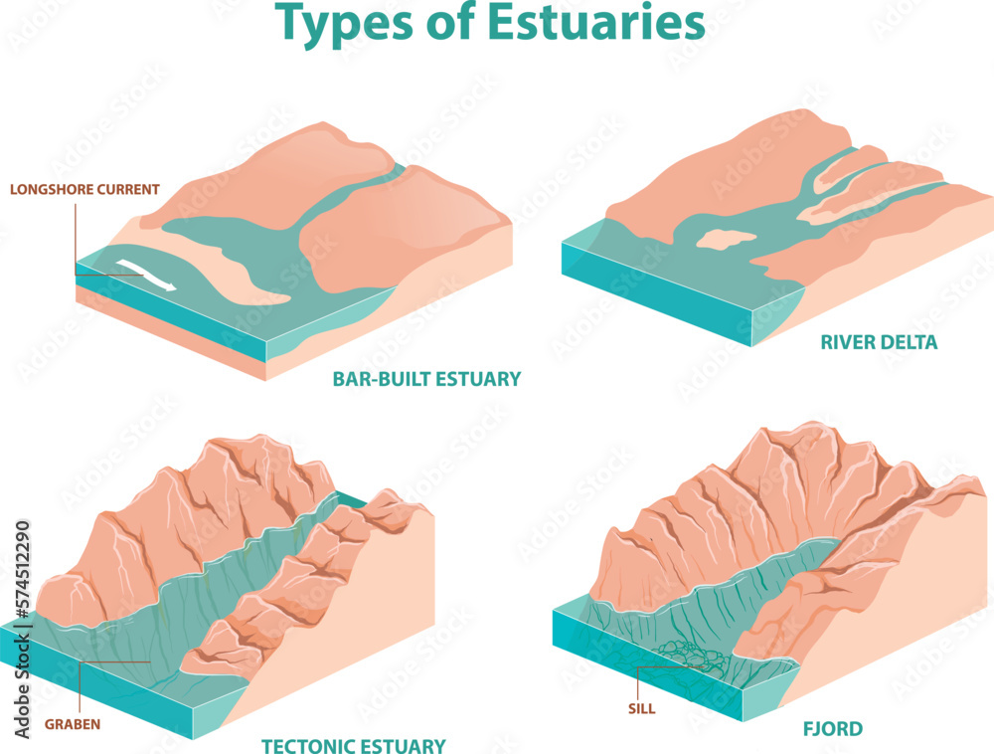

Wetlands:
- Wetlands – An area partly or fully covered with water, either seasonally or permanently. The water can come from groundwater, lakes or rivers, seawater, or heavy rains. Wetlands are places where land and water meet, creating a unique habitat. They are sanctuaries for many land and water animals.
- Swamps – Land areas with water-saturated soil or permanently flooded areas, often located near streams, lakes, rivers, or intertidal coastlines, and classified by the types of plants growing in them: herbaceous, shrub, or forest swamps.
- Freshwater Swamps – Low-lying areas or deep depressions inundated with freshwater, either seasonally or permanently.
- Saltwater Swamps – Typically located along coastal areas, filled with saltwater from strong tides.
- Mangrove Forest – Mangroves are trees and shrubs that thrive in warm, wet, and salty water, inhabiting estuaries and, under favorable conditions, expand to cover coastlines of the intertidal zone, forming mangrove forests. Most living things consist algae and seagrasses, microorganisms, invertebrates, fish, birds, reptiles and amphibians, mammals.
- Prop Roots – Aerial and horizontal roots that help the plant gain a foothold in unstable soil.
- Pneumatophores – Thin, tube-like or cone-shaped modified roots that grow vertically from the prop roots, reaching 20–50 cm above water level, aiding in gas exchange.
- Lenticels – Thousands of small breathing pores on the bark surface of pneumatophores where oxygen enters for root respiration.
- Threats to Mangrove Forests:
- Clearing – Portions or entire mangrove forests are cleared and filled for coastal development and agriculture.
- Pollution – Fertilizers, pesticides, sewage, plastic litter, and human-made chemicals carried as runoff from upstream.
- River Diversions and Changes – Construction of dams and alteration of stream and river flow for domestic, industrial, and irrigation purposes.
- Overexploitation – Occurs when the removal of plant and animal species exceeds their reproductive capacity.
- Climate Change – A stable sea level is crucial for long-term survival of mangrove forests.

Coral Reefs:
- Coral Reefs – Shallow-ocean habitats with stony and branching structures made of calcium carbonate, developed in warm, clear, shallow waters (70–85°F), featuring holes, crevices, and small caves that provide habitat for diverse animal species, making them one of the most diverse ecosystems on Earth.
- Hard Corals (Scleractinians) – These species are responsible for building reef structures; their polyps secrete a cup-shaped exoskeleton called calyx made of calcium carbonate, and reef-forming hard corals are known as hermatypic corals.
- Soft Corals (Octocorals) – They have a wood-like core and a soft, fleshy exterior for protection, producing sclerites to maintain shape; they may be solitary or form colonies ranging from small clusters to several meters high and weighing tons.
- Deep-Sea Corals – Also known as deep ocean reefs, they live in cold, deep ocean waters; their cnidarian skeletons form groves, thickets, patches, banks, and mounds that provide distinctive habitats for sea creatures, and they obtain food by filter-feeding on plankton and organic matter carried by ocean currents or suspended water.
- Corals live in shallow or deep water. Shallow corals can be hard or soft and are colorful. They get energy by catching zooplankton and from symbiotic algae (zooxanthellae) that live in their tissues. The coral colors come from the algae.
- Threats to Reef-Building Corals:
- Coral Bleaching – A phenomenon where corals lose their vibrant colors and turn white, which can be fatal if a large portion of the colony is affected, though recovery is possible if environmental conditions return to normal.
- Coral Survival and Zooxanthellae – The prolonged existence of reef-building corals in shallow waters depends on the microscopic algae zooxanthellae, and changes in temperature, light, or nutrients can cause prolonged physiological stress to corals.
- Living Things That Inhabit Coral Reefs:
- Producers – Phytoplankton, zooxanthellae, blue-green algae, seaweeds, and seagrasses are the primary producers of the coral reef ecosystem.
- Herbivores – Zooplanktons are the most abundant herbivores, including protozoa, krill, fish eggs and larvae, dinoflagellates, and other small animals; small primary consumers include mollusks, echinoderms, and sponges, while larger herbivores include crabs, green sea turtles, and some herbivorous fish that are permanent reef residents.
- Carnivores – Top carnivores are fast, agile swimmers and skilled predators, including fish species such as eels, barracuda, sharks, rays, large sea bass, large red snappers, trumpet fish, and tuna; crustaceans like crabs, lobsters, barnacles, and shrimps; as well as fat worms, ribbon worms, mollusks, and echinoderms.
- Types of Coral Reef Formation
- Fringing or Shore Reef – Grows close to the shore around islands and continents, in shallow waters with heavy sediment accumulation, divided into the reef flat and reef slope, with the reef slope facing the ocean and containing diverse marine life; as the reef approaches the shore, erosion forms a bowl-like depression that becomes a lagoon when filled with seawater.
- Barrier Reef – Similar to a fringing reef, but the lagoon separating it from the shore is deeper and hundreds of meters wide; during low tides, the reef protrudes above water, forming a wall-like barrier.
- Atoll Reef – Consists of small reef islands arranged circularly, enclosing a central lagoon, forming in the middle of the ocean; believed to form when a fringing reef-surrounded island sinks due to sea level rise or from the tops of underwater volcanoes, with fringing reefs continuing to grow around the lagoon.
- Threats to Coral Reefs:
- Sedimentation – Rain and floods wash and transport sediments into bodies of water, which are carried to the ocean.
- Overexploitation of Marine Resources – Includes overfishing and unsustainable fishing practices.
- Pollution – The addition of harmful chemicals that suffocate corals and kill plants and animals in the coral reefs.

Impacts of Human Activities in an Ecosystem:
- Habitat Destruction – Deforestation increases soil erosion, shortens food chains, isolates trophic levels, disrupts the water cycle, reduces carbon dioxide absorption, diminishes breeding grounds in wetlands, and confuses animals, disrupting their natural way of living.
- Overharvesting – The unsustainable removal of natural resources faster than species can reproduce, leading to environmental damage, reduction in ecosystem services, disruption of aquatic food chains, and loss of natural sources for drugs and medicines.
- Introduction of Exotic, Alien, or Non-native Species – Plants and animals introduced outside their natural geographic range become invasive if they grow and reproduce rapidly, spread quickly, adapt easily, survive on various foods, and lack natural predators; these species can alter biodiversity, change food webs, affect soil composition, and increase threats to ecosystems.
- Pollution (Atmosphere, Water, and Land) – Human-caused pollution poses a threat to biodiversity in all forms.
- Acid Precipitation – Pertains to any form of precipitation that is more acidic than usual.
- Water Pollution – Caused by substances carried through leaching or runoff.
- Climate Change – An effect of global warming, described as the shift from existing climate patterns to abnormal patterns.

